**Installing cellpose**

First install anaconda3 – we will use the anaconda prompt in this package. After installing you can find it by searching in your programs

Then to download cellpose, type this into the command line

conda create -n cellpose pytorch=1.8.2 cudatoolkit=10.2 -c pytorch-lts

conda activate cellpose

pip install cellpose

Once installed successfully – you will see a cellpose environment in your c drive and then you can go

Conda activate cellpose – which changes your base environment to cellpose

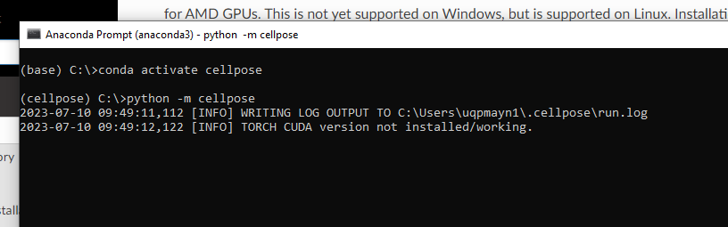

And then go:

python -m cellpose

And this will open the GUI

Once we have trained the network to suit our images we can batch the images in a folder with using the command line. Examples below

For example: images where cytoplasm is green and nucleus is blue and save the output as a png (using default diameter 30):

python -m cellpose --dir ~/images_cyto/test/ --pretrained_model cyto --chan 2 --chan2 3 --save_png

For example: images where you are just doing one channel (no need to specify), use the models diameter for all images and save the output as a tiff

python -m cellpose --dir C:/Users/uqpmayn1/Desktop/Dapi --pretrained_model C:/Users/uqpmayn1/Desktop/DapiModel/CP_230000 --diameter 0 --save_tiff --verbose